Assignment M4

Lu Han  
lhan72@gatech.edu

***Abstract—***Zara is a popular fast fashion brand but its website suffers from low usability and bad user experience. In the needfinding study, it was found there was a huge gulf of execution and evaluation within the interface. This project aims to redesign the website interface and improve its functionality and usability. The project will focus on the task of shopping on Zara website which includes the subtask of searching for products, viewing search results, filtering and sorting the results and etc. The task and subtasks will be analyzed and several potential solutions will be examined to improve the user experience within the interface.

# qualitative evaluation

In assignment M3, a paper prototype was proposed to help user complete the task of looking for products on Zara website. The header redesign was inspired by the survey results in the M2 that more than 50% of the participants had challenges when looking for products and the satisfaction level was low for the searching and navigation functions. In addition, some of the comments from think aloud methods and surveys showed that users had difficulty to find their saved items in the wish list and don’t know where the wish list is. To tackle these challenges, the redesign of the website header decluttered the wish list from the shopping bag and make it with the signifier icon. The signifier icons show the wish list and shopping bag side by side and it might be easier for user to discover them comparing to composing them into one icon. At the same time, the product categories were decluttered into the header bar showing the categories of “women””men””kids” and “beauty” which makes it more discoverable for the user to find the right category.

The goal of the qualitative evaluation is to find out if the redesign of the header of Zara website can help the user better navigate through the website and search for the products, and also makes it easier to find the saved items in the wish list. The survey will be published on the peer survey website as M2 and will be conducted among the classmates mostly. This may introduce some bias from the

1. Survey questions for the paper prototype of Zara header interface redesign

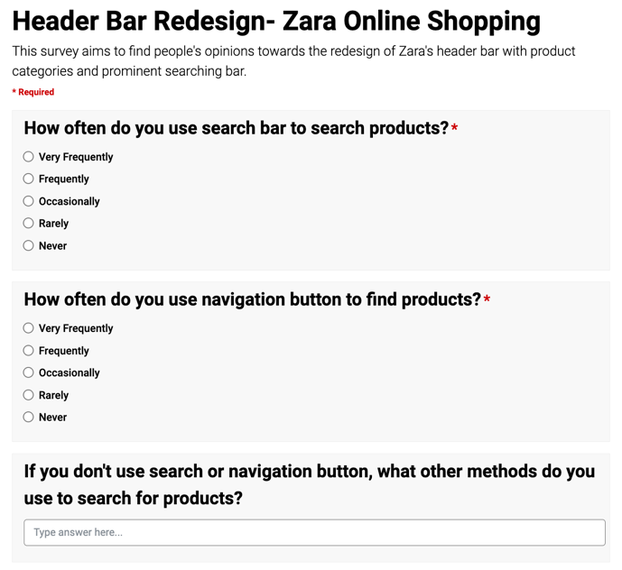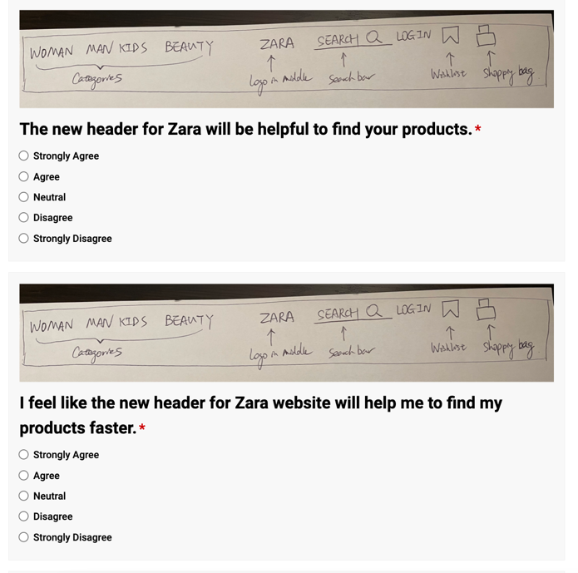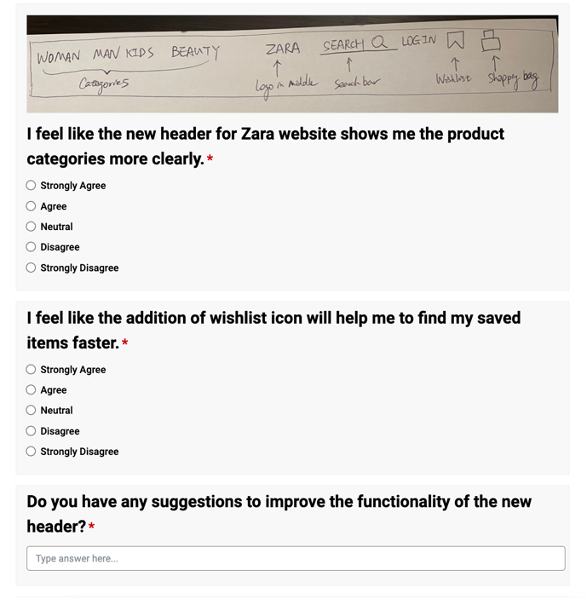

participants as they might have similar age group or the gender is not well distributed. In future, the survey can be conducted in the public with a high fidelity prototype to gather more representative data from the public users. The participants will be recruited on the Ed discussion forum. I will post a thread recruiting for participants for the survey. If there is not enough responses from classmates, I will also post the thread of participants recruiting on the reddit OMSCS forum. Last time I posted the M2 survey on the forum and got some responses from it. As the evaluation format is in survey format, it will take place online and virtually. No face to face evaluation is needed in the survey. The results will be recorded online through the peer survey website and the data gathered will be analyzed by excel. The data will gather participants’ opinions of the redesign of interface and see how it helps them to search products, navigate the categories and find saved items. The survey will also ask for people’s opinion about whether the interface will help them search products, help to find the products faster and motivate them to use the interface more frequently. It also helps to see if the users will be satisfied with the redesign of the interface. The actual contents of the survey is attached in figure 1.

This qualitative evaluation will help us better understand our users and data inventory. For example, the questions ask about how they feel the new interface helps them to search and navigate the product categories. It will help us to understand the task of searching products and subtask of navigating through product categories. In addition, it might also help us to better understand the user’s needs and goals when shopping on Zara website. The functionality and usability of the website might be more priority to users rather than the fancy design. Because sometimes the fancy design places a huge gulf of execution and evaluation between user and interface.

# empirical evaluation

A wireframing prototype was proposed in the M3 assignment. The prototype shows the interface of product overview with sort and filter features. The task

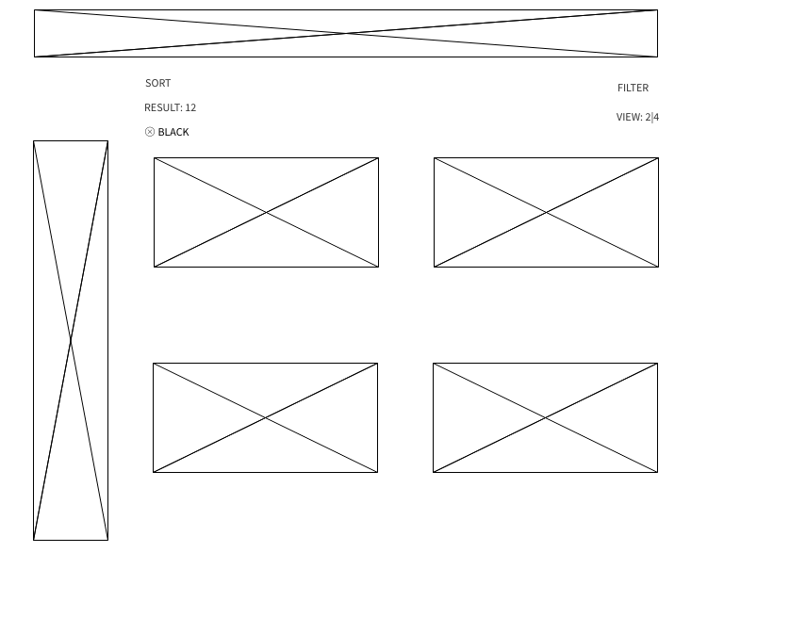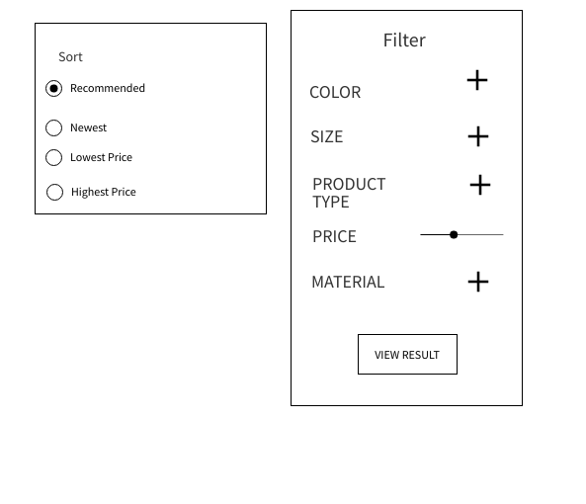

1. Prototype of product overview page with sort and filter features.

for user is to filter and sort the products according to their own preferences such as price, new items, color and etc. I have to assume this prototype is an interactive prototype so that the empirical evaluation can be done. So the user will be able to interact with the prototype in the experiment and comparisons can be done with the original Zara website.

The experiment will have a control and experiment group. The control group will be using the original Zara website’s filtering function and sorting function. The experimental group will be using the new prototype interface to complete the same task as control group. I am going to time them when they are doing the specific task. I give them a task to find out the black, size XL, minis skirt with the lowest price. I will record the time they take and the number of errors they make when they are doing the task.

So my null hypothesis will be: the average time they take to finish the task of control group equals to experimental group. And the alternative hypothesis will be: the average time they take to finish the task of control group doesn’t equal to experimental group. I will use the method of student t-test to analyze the data. as the IV is categorical and DV is ratio and it’s only 2 treatments. The test will be between subjects. The two treatments of Zara website and the prototype will be assigned to the same group of participants. They will complete the task of filtering products according to the requirement and the time they finish the task will be collected as data. However there are many variables that can compromise the evaluation. For example, the subjects are mostly classmates and the age is around 18-29 which might produce some bias to the results as young people tend to react faster than older people. In future study, a more comprehensive study group from different ages, cultures and genders can be included in the survey to avoid the bias from the subject group.

# predictive evaluation

1. Card prototype of Zara website interface

As the textual prototype in M3 is hard to evaluate with the predictive evaluation. I made some variations to my paper prototype and made it into a card prototype so it will be easy for me to go through either a cognitive walkthrough or GOMS model and it was attached in figure 3. The goal for the user is to search and navigate through the categories to find a target product. He also wants to narrow down the results by sorting and filtering the results and save some items to wish list before he confirms which one to purchase.

A cognitive walkthrough will be conducted to evaluate the process. Assume the users are novice and don’t know what to do in advance. I will act and think in the user’s shoes and mimic his cognitive process and navigate around the interface to figure out how to accomplish the goal. For the first step the goal is to look for a product on the website. The task will be either using a search bar to search for product or use the category navigation button to look for the product directly. To accomplish the task, I should answer the question of whether the user is able to discover the search bar and navigation button at first. To achieve the discoverability, the buttons are signified by the capitalized labels with “women” ”men” and etc. And the searching bar was signified by the label of “search” and an icon of magnifying glass. The next question to ask is whether they get the feedback and how well they can interpret it. This is to test the gulf of evaluation. When they type something in the searching bar, the searching bar will automatically show some suggested results. Even though the user might make a slip error by typing in “dreass” instead of “dress”, the bar will still show “dress” underneath the searching bar to correct the slip.

Next the user might want to view the searching result in the overview page and adjust the view grid size. The task will be adjust the view size and the operators of view adjusting should be available to them. The view button was labeled as “view” with a number of “2” and “4” beside it. So when the user press the button, he can predict what the page will look like as the number indicates the number of pictures per row. Comparing to the original slide bar without any labels, this new view button affords people to press and predicts the outcome itself.

The user might also want to narrow down the results by sorting and filtering the results. The sort and filter buttons are self-explanatory. In the filter, there are some subtasks of choosing the sub-filter. The sub-filters were signified with “+” icon that enable the user to understand its function. After selecting the filtering criteria, the user will notice the view result button affords the user to press it and in this way the user will be able to see the filtering results and the number of results showing on the screen.

With the bookmark on the product overview page, it shows the option for a wish list so that the user can decide later which item to buy. The goal is to save favorite items into a list and view them later. So the task is to add the items into the wish list. A operator of book icon to add item to wish list is available to the user. After pressing the bookmark icon, a button showing “view wish list” will show up above the bookmark, indicating the item was added successfully.

# Preparing execution

In the next assignment, two evaluation methods are selected to evaluate the prototypes. One is qualitative evaluation and the other is predictive evaluation. The empirical evaluation is removed as the prototype is in the preliminary stage and not interactive to gather the empirical data to compare with the original interface. To gather the time for the user to interact with certain features on interface, an interactive prototype is needed to achieve an accurate result.

Qualitative and predictive evaluations are feasible based on the current prototype. The survey is selected and it can give qualitative data to meet the data inventory requirements. The cognitive walkthrough is selected to stand in the user’s shoes and see whether there are gulf of execution and evaluation. Both evaluation findings will be helpful to iterate to the next round of needfinding process.